10.4 Render - Camera
Camera 1
Changing the Active Camera 1
Camera Settings 2
Lens 2
Camera 2
Depth of Field 3
Display 4
Composition Guides 5
Safe Areas 6
Render Border 6
Camera Lens 7
Lens Types 7
Perspective 7
Orthographic 9
Panoramic 9
Shift 9
Clipping 10
Safe Areas 11
Main Safe Areas 12
Center-Cuts 13

Camera

A Camera is an object that provides a means of rendering images from Bforartists. It defines which portions of a scene is visible in the rendered image. By default a scene contains one camera. However, A scene can contain more than one camera, but only one of them will be used at a time. So you will only need to add a new camera if you are making cuts between them. See Animating Cameras.

Changing the Active Camera
Reference
Mode: Object mode
Hotkey: Ctrl-Numpad0

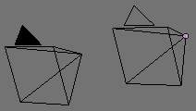
Active camera (left one).
The active camera is the camera that is currently being used for rendering and camera view (Numpad0).
Select the camera you would like to make active and press Ctrl-Numpad0 (by doing so, you also switch the view to camera view). In order to render, each scene must have an active camera.
The active camera can also be set in the Scene context of the Properties Editor
The camera with the solid triangle on top is the active camera.
Warning
The active camera, as well as the layers, can be specific to a given view, or global (locked) to the whole scene - see Local Camera.

Camera Settings
Reference
Mode: Object mode
Editor: Properties
Context: Object Data

Cameras are invisible in renders, so they don’t have any material or texture settings. However, they do have Object and Editing setting panels available which are displayed when a camera is the selected (active!) object.

Lens
The camera lens options control the way 3D objects are represented in a 2D image. See Camera Lens for details.

Camera
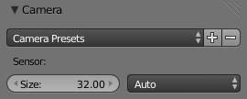
Camera Presets panel.
Sensor size
This setting is an alternative way to control the focal-length, it’s useful to match the camera in Bforartists to a physical camera & lens combination, e.g. for motion tracking.

Depth of Field
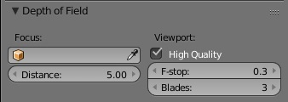
Camera Depth of Field Panel
Real world cameras transmit light through a lens that bends and focuses it onto the sensor. Because of this, objects that are a certain distance away are in focus, but objects in front and behind that are blurred.
The area in focus is called the focal point and can be set using either an exact value, or by using the distance between the camera and a chosen object:
Focus Object
Choose an object which will determine the focal point. Linking an object will deactivate the distance parameter. Typically this is used to give precise control over the position of the focal point, and also allows it to be animated or constrained to another object.
Distance
Sets the distance to the focal point when no Focus Object is specified. If Limits are enabled, a yellow cross is shown on the camera line of sight at this distance.
Hint
Hover the mouse over the Distance property and press E to use a special Depth Picker. Then click on a point in the 3D View to sample the distance from that point to the camera.

High Quality
In order for the viewport to offer an accurate representation of depth of field, like a render, you must enable High Quality. Without it, you may notice a difference in shading.
Viewport F-stop
Controls the real-time focal blur effect used during sequencer or OpenGL rendering and, when enabled, camera views in the 3D viewport. The amount of blur depends on this setting, along with Focal Length and Sensor Size. Smaller Viewport F-stop values result in more blur.
Blades
Add a number of polygonal blades to the blur effect, in order to achieve a a bokeh effect in the viewport. To enable this feature, the blades must be set to at least 3 (3 sides, triangle)
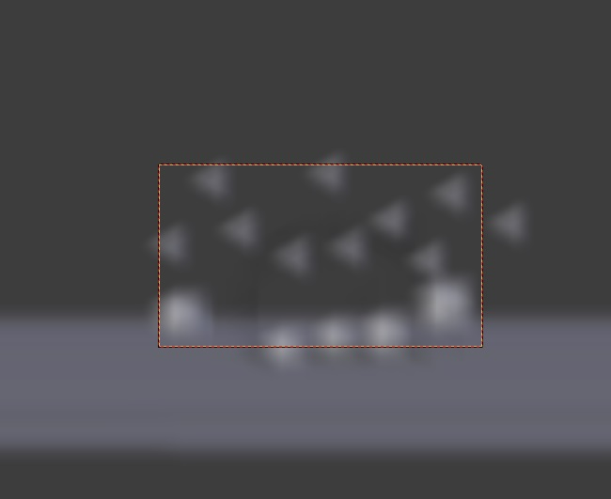
The viewport bokeh effect with the blades set to 3

Display
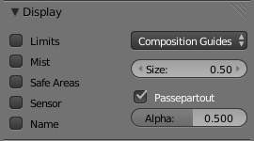
Camera Display panel
Limits
Shows a line which indicates Start and End Clipping values.
Mist
Toggles viewing of the mist limits on and off. The limits are shown as two connected white dots on the camera line of sight. The mist limits and other options are set in the World panel, in the Mist section.
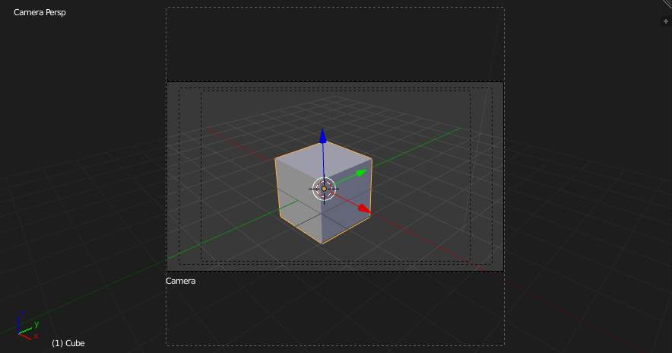
Camera view displaying safe areas, sensor and name
Sensor
Displays a dotted frame in camera view.
Name
Toggle name display on and off in camera view.
Size
Size of the camera icon in the 3D view. This setting has no effect on the render output of a camera, and is only a cosmetic setting. The camera icon can also be scaled using the standard Scale S transform key.
Passepartout, Alpha
This mode darkens the area outside of the camera’s field of view, based on the Alpha setting.

Composition Guides
Composition Guides are available from the drop-down menu, which can help when framing a shot. There are 8 types of guides available:
Center
Adds lines dividing the frame in half vertically and horizontally.
Center Diagonal
Adds lines connecting opposite corners.
Thirds
Adds lines dividing the frame in thirds vertically and horizontally.
Golden
Divides the width and height into Golden proportions (About 0.618 of the size from all sides of the frame).
Golden Triangle A
Draws a diagonal line from the lower-left to upper-right corners, then adds perpendicular lines that pass through the top left and bottom right corners.
Golden Triangle B
Same as A, but with the opposite corners.
Harmonious Triangle A
Draws a diagonal line from the lower-left to upper-right corners, then lines from the top left and bottom right corners to 0.618 the lengths of the opposite side.
Harmonious Triangle B
Same as A, but with the opposite corners.

Safe Areas
When this is enabled, extra dotted frames are drawn when in camera view, delimiting the area considered as “safe” for important elements. More information about them in the safe areas section.

Render Border
Reference
Mode: All modes
Menu: View ‣ Render Border
Hotkey: Ctrl-B

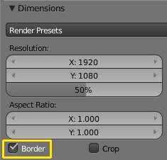
Render Border toggle
While in camera view, you can define a subregion to render by drawing out a rectangle within the cameras frame. Your renders will now be limited to the part of scene visible within the render border. This can be very useful for reducing render times for quick previews on an area of interest.
The border can be disabled by disabling the Border option in the Dimensions panel of the Render context or by activating the option again and selecting Render Border larger than the camera view.
Note
Anti-Aliasing and blur options with borders
Note that when Render Borders are activated, Full Sampling Anti-Aliasing will be disabled while Sampled Motion Blur will become available.
Read more about Anti-Aliasing Read more about Motion Blur

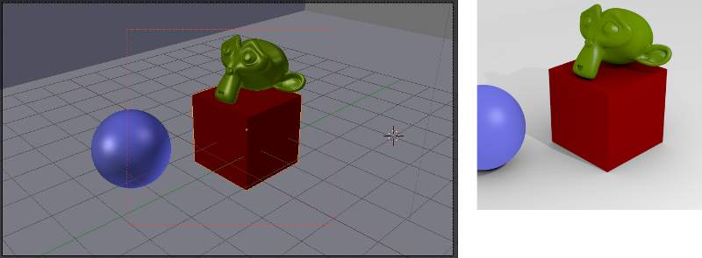
Render border and associated render.

Camera Lens

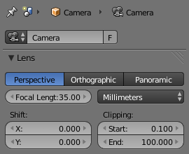
Camera Lens panel.
The camera lens options control the way 3D objects are represented in a 2D image.

Lens Types
There are three different lens types:
- Perspective
- Orthographic
- Panoramic

Perspective
This matches how you view things in the real-world. Objects in the distance will appear smaller than objects in the foreground, and parallel lines (such as the rails on a railroad) will appear to converge as they get farther away.
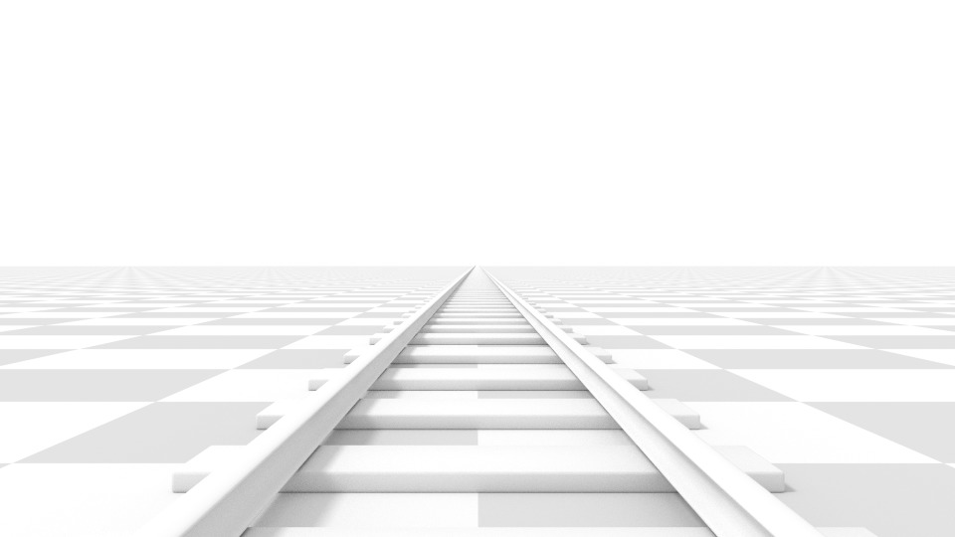
Render of a train track scene with a Perspective camera.
Settings which adjust this projection include:
- Focal length
- Shift
- Sensor size
Focal length
The focal length setting controls the amount of zoom, i.e. the amount of the scene which is visible all at once. Longer focal lengths result in a smaller FOV (more zoom), while short focal lengths allow you to see more of the scene at once (larger FOV, less zoom).
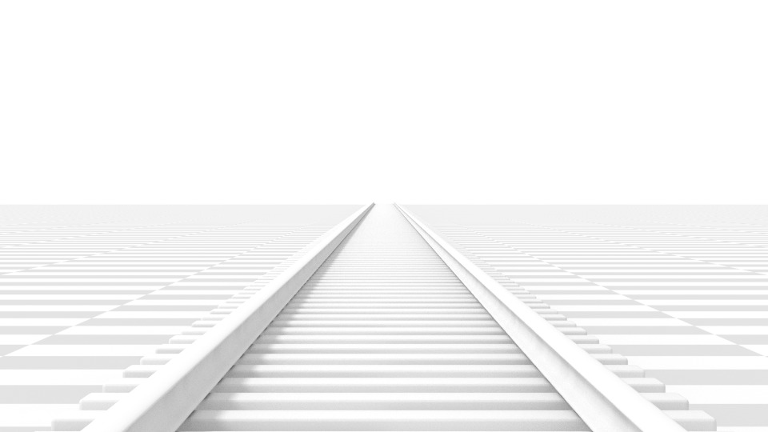
Render of the same scene as above, but with a focal length of 210mm instead of 35mm.
Lens Unit
The focal length can be set either in terms of millimeters or the actual Field of View as an angle.

Orthographic
With Orthographic perspective objects always appear at their actual size, regardless of distance. This means that parallel lines appear parallel, and do not converge like they do with Perspective.
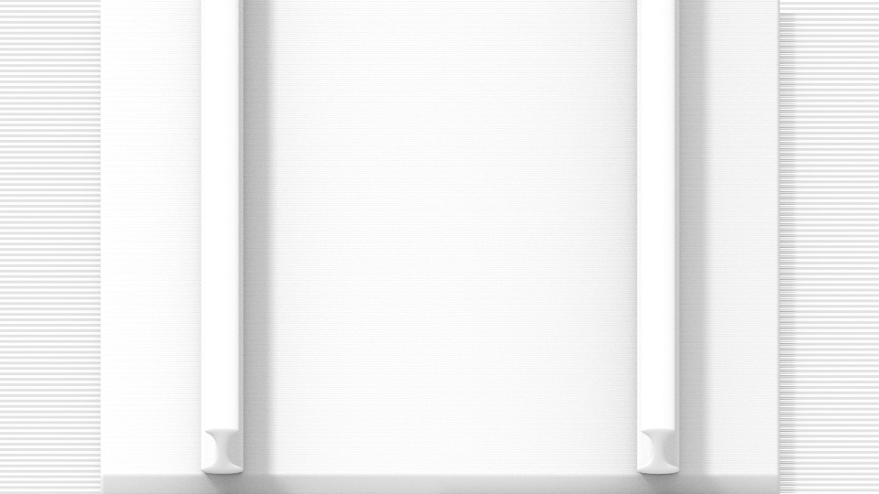
Render from the same camera angle as the previous examples, but with orthographic perspective.
Orthographic Scale
This controls the apparent size of objects in the camera.
Note that this is effectively the only setting which applies to orthographic perspective. Since parallel lines do not converge in orthographic mode (no vanishing points), the lens shift settings are equivalent to translating the camera in the 3D view.

Panoramic
Panoramic cameras are only supported in the Cycles render engine. See the Cycles documentation.

Shift
The Shift setting allows for the adjustment of vanishing points. Vanishing points refer to the positions to which parallel lines converge. In this example, the most obvious vanishing point is at the end of the railroad.
To see how this works, take the following examples:
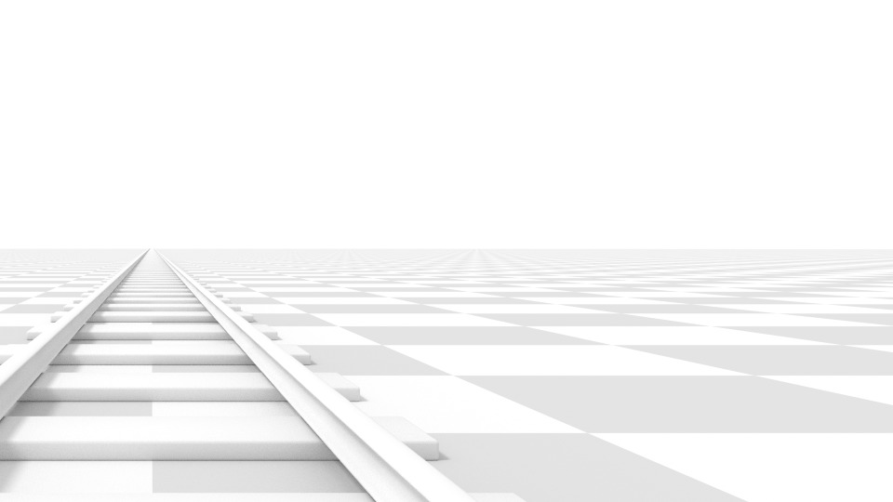
Render of a train track scene with a horizontal lens shift of 0.330.
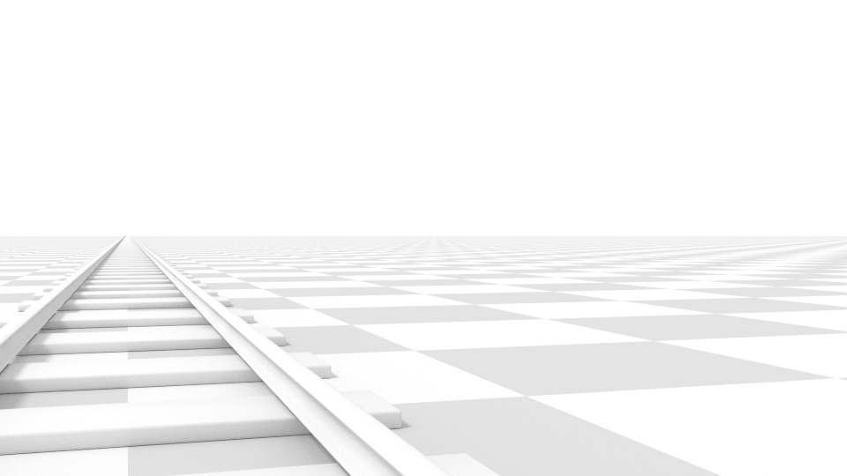
Render of a train track scene with a rotation of the camera object instead of a lens shift.
Notice how the horizontal lines remain perfectly horizontal when using the lens shift, but do get skewed when rotating the camera object.
Using lens shift is equivalent to rendering an image with a larger FOV and cropping it off-center.

Clipping
Set the clipping limits with the Start and End values.
Only objects within the limits are rendered.
For OpenGL display, setting clipping distances to limited values is important to ensure sufficient rasterization precision. Ray tracing renders don’t suffer from this issue so much, and as such more extreme values can safely be set.
When Limits in the Display panel is enabled, the clip bounds will be visible as two yellow connected dots on the camera line of sight.
Note
The 3D View window contains settings similar to the camera, see the 3D view options page for more details.

Safe Areas

Safe areas are guides used to position elements to ensure that the most important parts of the content can be seen across all screens.
Different screens have varying amounts of overscan. (specially older TV sets). That means that not all content will be visible to all viewers, since parts of the image surrounding the edges are not shown. To work around this problem TV producers defined two areas where content is guaranteed to be shown: action safe and title safe.
Modern LCD/plasma screens with purely digital signals have no overscan, yet safe areas are still considered best practice and may be legally required for broadcast.
In Bforartists, safe areas can be set from the Camera and Sequencer views.
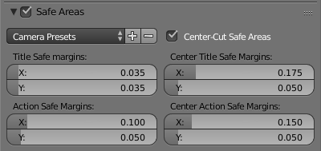
The Safe areas panel found in the camera properties, and the view mode of the sequencer.

Main Safe Areas
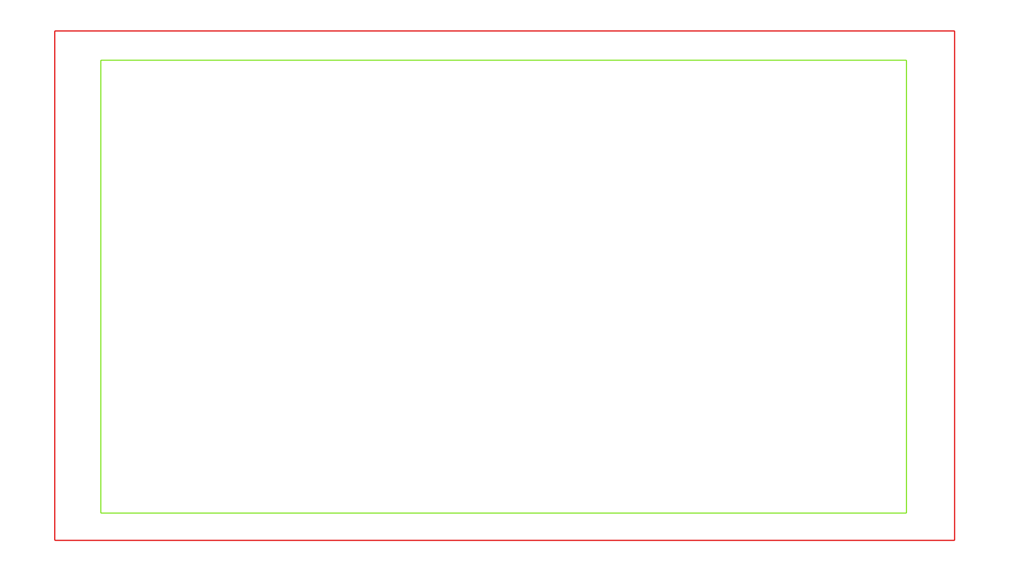
Red line: Action safe. Green line: Title safe
Title Safe
Also known as Graphics Safe. Place all important information (graphics or text) inside this area to ensure it can be seen by the majority of viewers.
Action Safe
Make sure any significant action or characters in the shot are inside this area. This zone also doubles as a sort of “margin” for the screen which can be used to keep elements from piling up against the edges.
Tip
Legal Standards
Each country sets a legal standard for broadcasting. These include, among other things, specific values for safe areas. Bforartists defaults for safe areas follow the EBU (European Union) standard. Make sure you’re using the correct values when working for broadcast to avoid any trouble.

Center-Cuts
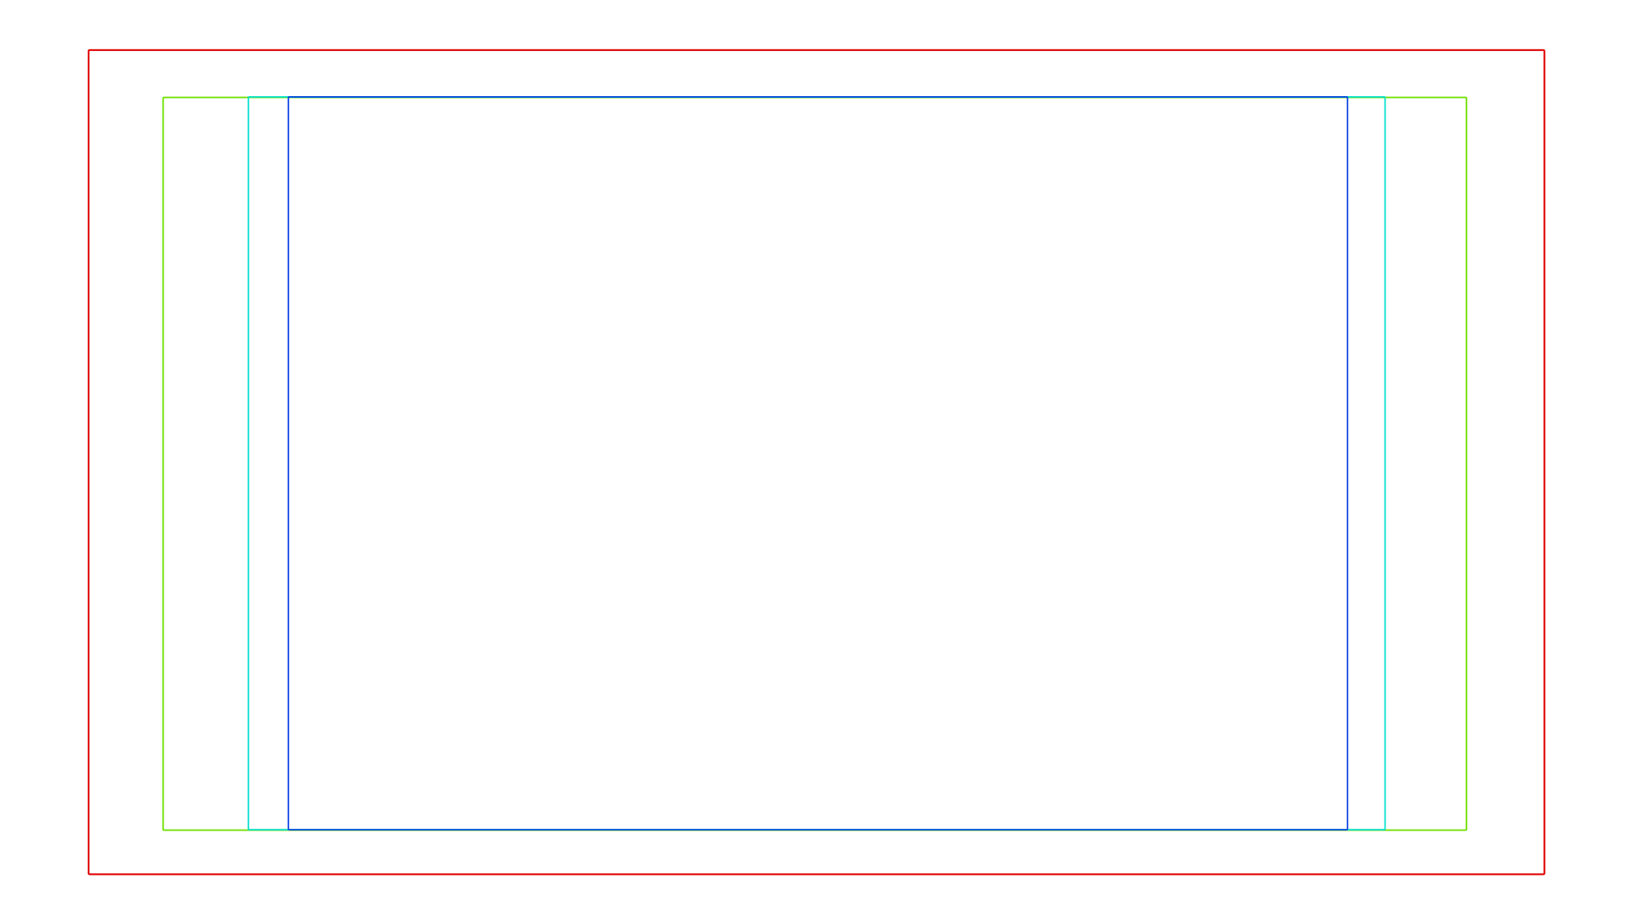
Cyan line: action center safe. Blue line: title center safe
Center-cuts are a second set of safe areas to ensure content is seen correctly on screens with a different aspect ratio. Old TV sets receiving 16:9 or 21:9 video will cut off the sides. Position content inside the center-cut areas to make sure the most important elements of your composition can still be visible in these screens.
Bforartists defaults show a 4:3 (square) ratio inside 16:9 (wide-screen).

